1. Displaying all values in View 1(CustomerBill)

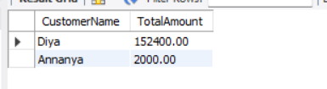

1. Displaying values in View 1 having TotalAmount more than 5000.

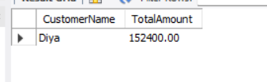

1. Displaying all values in View 2(MonthlySales)

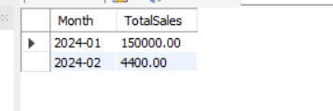

1. Displaying values in View 2 having TotalAmount more than 10000.

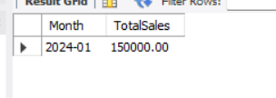

1. Displaying all values in View 3(TopCustomers)

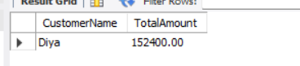

1. Displaying all values in View 4(ProductSales)

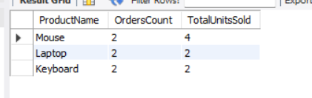

1. Displaying Total Units Sold for Each Product

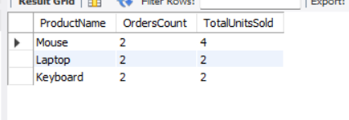

1. Join View with Tables

